DBMS PROJECT

ON

LIBRARY MANAGEMENT SYSTEM

DATABASE DESIGN

SUBMITTED BY:

SAI KUMAR KANTHALA

191153

kantha_811945@student.nitw.ac.in

**PROBLEM STATEMENT:**

Library Management Systems are a great way to monitor books, add them, update information in it, search for the suitable one, issue it, and return it when needed. This Library Management System Project is to provide all the features that a Library Management System should usually have and overcome the drawbacks of the present system such as:

* Paper-based record keeping.
* Mis-management of data due to manual and paper-based handling.
* A vast amount of time consumption in searching for books and library management.
* Book-thefts from the library.

**FACTS and ASSUMPTIONS:**

1. Two books can have a same title written by different authors.
2. ISBN uniquely identify the books.
3. Authors cannot have same name, as they use initials of their first name and middle name in their name to differentiate them from others.
4. Two Different publishers cannot have same Publishing name.
5. Salary of an employee in a particular designation will be determined by his date of joining.
6. Here we declared fixed salary for a particular designation.
7. Due date of a book to return is determined by the issued date.

**ER DIAGRAM:**

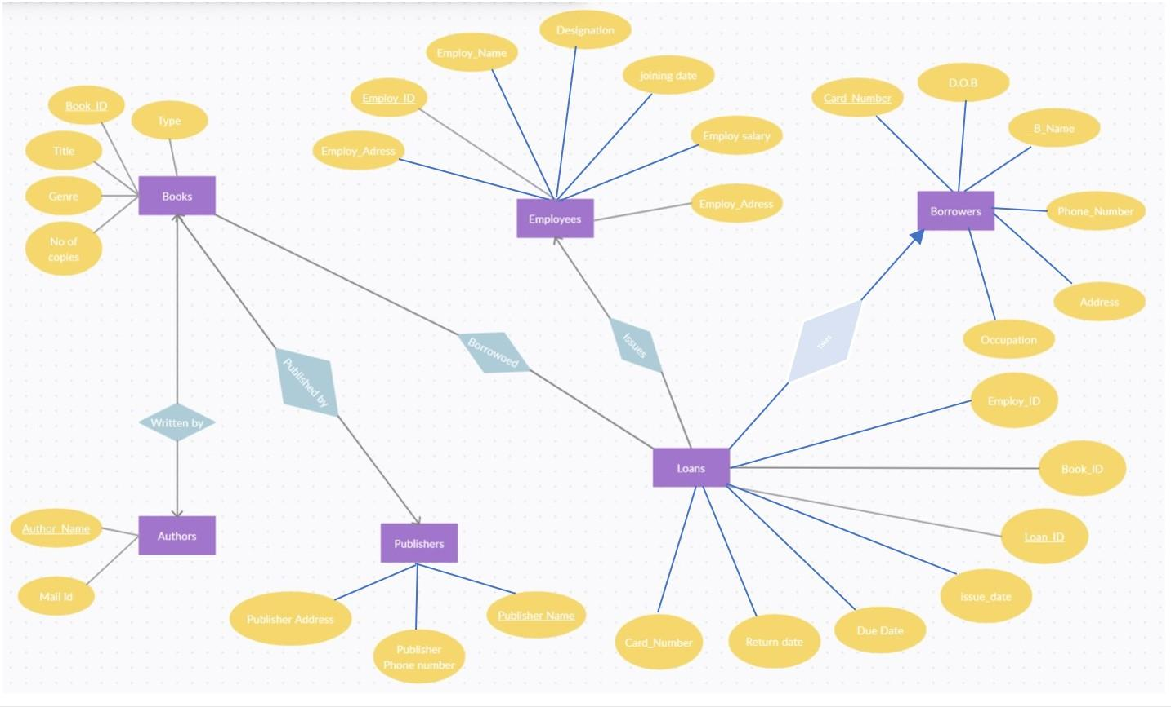

**ENTITIES**

Books

Authors

Publishers

Employees

Borrowers

Loans

**RELATIONS**

Written By

Published By

Book Borrowed

Issued By

Borrowed by

ER DIAGRAM: [Link](https://drive.google.com/file/d/13J8an9TT89sV2lXvVNcHKcUjqKAb_iVp/view?usp=sharing)

**RELATIONAL MODEL:**

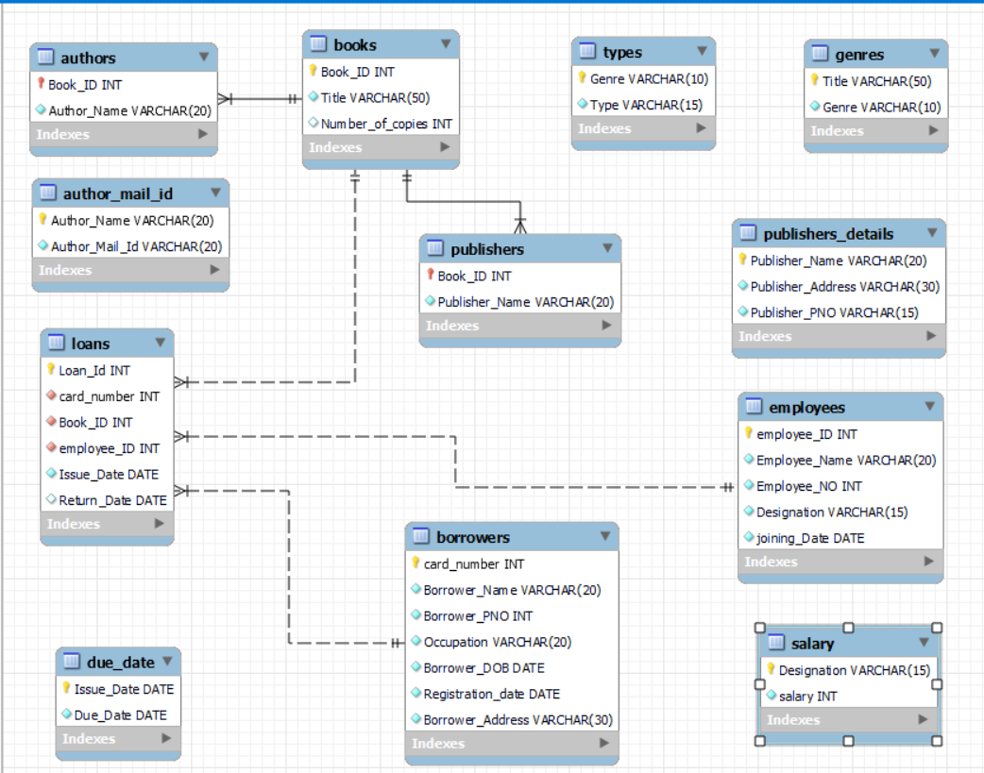

RELATIONAL MODEL: [Link](https://drive.google.com/file/d/1mcqJRuFpLRRglPFdM6KcMV6ANq17fUSD/view?usp=sharing)

**FUNCTIONAL DEPENDENCIES AND TABLES BEFORE NORMALIZATION:**

* 1. **BOOKS:**

(Book_ID,Title,Genre,Type,Number_of_copies)

Book_ID-> Title, Number_of_copies

Title->Genre

Genre->Type

Normal form: 2NF

* 1. **AUTHORS:**

(Book_ID,Author_Name,Author_Mail_ID)

Book_ID->Author_Name

Author_Name->Author_Mail_ID

Normal form: 2NF

* 1. **PUBLISHERS:**

(Book_ID,Publisher_Name,Publisher_Address,Publisher_PNO)

Book_ID-> Publisher_Name

Publisher_Name-> Publisher_Address,Publisher_PNO

Normal form: 2NF

* 1. **EMPLOYEES:**

(Employee_ID,Employee_Name,Employee_PNO,Designation,

Salary,Joining_Date)

Employee_ID->Employee_Name,Employee_PNO,Designation,

Salary,Joining_Date

Normal form: 2NF

* 1. **BORROWERS:**

(Card_Number,Borrower_Name,Borrower_PNO,Occupation,

Borrower_DOB,Registration_Date,Borrower_Address)

Card_Number->Borrower_Name,Borrower_PNO,Occupation,

Borrower_DOB,Registration_Date,Borrower_Address

Normal form: BCNF

* 1. **LOANS:**

(Loan_ID,Card_Number,Book_ID,Employee_ID,Issue_date,

Due_date,Return_Date)

Loan_ID->Card_Number,Book_ID,Employee_ID,Issue_date,

Return_Date

Issue_Date->Due_Date

Normal Form:2NF

**FUNCTIONAL DEPENDENCIES AND TABLES AFTER NORMALIZATION:**

**Books table** after normalization decomposed into

**Books, Genre, Type**

1. **BOOKS:**

(Book_ID, Title, Number_of_copies)

Book_ID->Title,Number_of_copies

Normal form: BCNF

1. **Genres:**

(Title,Genre)

Title->Genre

Normal form: BCNF

1. **Types:**

(Genre, Type)

Genre->Type

Normal form: BCNF

**Authors table** after normalization decomposed into

**Author, Author Mail ID**

1. **AUTHORS:**

(Book_ID, Author_Name)

Book_ID->Author_Name

Normal form: BCNF

1. **Author Mail ID:**

(Author_Name, Author_Mail_ID)

Author_Name->Author_Mail_ID

Normal form: BCNF

**Publisher table** after normalization decomposed into

**Publisher Name, Publisher Details**

1. **PUBLISHERS:**

(Book_ID, Publisher_Name)

Book_ID->Publisher_Name

Normal form: BCNF

1. **PUBLISHER DETAILS:**

(Publisher_Name, Publisher_Address, Publisher_PNO)

Publisher_Name->Publisher_Address,Publisher_PNO

Normal form: BCNF

**Employee** **table** after normalization decomposed into

**Employee, Salary**

1. **EMPLOYEES:**

(Employee_ID, Employee_Name, Employee_PNO, Designation,

Joining_Date)

Employee_ID->Employee_Name, Employee_PNO, Designation,

Joining_Date

Normal form: BCNF

1. **SALARY:**

(Designation, Salary)

Designation->Salary

Normal form: BCNF

1. **BORROWERS:**

(Card_Number,Borrower_Name,Borrower_PNO,Occupation,

Borrower_DOB,Registration_Date,Borrower_Address)

Card_Number->Borrower_Name,Borrower_PNO,Occupation,

Borrower_DOB,Registration_Date,Borrower_Address

Normal form: BCNF

**Loans** **table** after normalization decomposed into

**Loans, Due Date**

1. **LOANS:**

(Loan_ID, Card_Number, Book_ID, Employee_ID, Issue_date,

Return_Date)

Loan_ID->Card_Number, Book_ID, Employee_ID, Issue_date,

Return_Date

Normal form: BCNF

1. **DUE DATE:**

(Issue_Date,Due_Date)

Issue_Date->Due_Date

Normal form: BCNF

**IMPLEMENTATION IN SQL**

CREATE DATABASE library;

USE library;

CREATE TABLE Books (

Book_ID int NOT NULL,

Title varchar(50) not null,

Number_of_copies int,

PRIMARY KEY (Book_ID)

);

CREATE TABLE Genres(

Title varchar(50) NOT NULL,

Genre varchar(10) NOT NULL,

PRIMARY KEY (Title)

);

CREATE TABLE Types(

Genre varchar(10) NOT NULL,

Type varchar(15) not null,

PRIMARY KEY (Genre)

);

CREATE TABLE Authors(

Book_ID int NOT NULL primary key,

Author_Name varchar(20) not null,

foreign key(Book_ID) references Books(Book_ID)

);

create table Author_Mail_Id(

Author_Name varchar(20) not null primary key,

Author_Mail_Id varchar(20) not null

);

create table Publishers(

Book_ID int NOT NULL primary key,

Publisher_Name varchar(20) not null,

foreign key(Book_ID) references Books(Book_ID)

);

create table Publishers_Details(

Publisher_Name varchar(20) not null primary key,

Publisher_Address varchar(30) not null,

Publisher_PNO varchar(15) not null

);

create table employees(

employee_ID int primary key,

Employee_Name varchar(20) not null,

Employee_NO int not null,

Designation varchar(15) not null,

joining_Date date not null

);

create table salary(

Designation varchar(15) not null primary key,

salary int not null

);

create table borrowers(

card_number int not null primary key,

Borrower_Name varchar(20) not null,

Borrower_PNO int not null,

Occupation varchar(20) not null,

Borrower_DOB date not null,

Registration_date date not null,

Borrower_Address varchar(30) not null

);

create table loans(

Loan_Id int not null primary key,

card_number int not null,

Book_ID int NOT NULL,

employee_ID int not null,

Issue_Date date not null,

Return_Date date,

foreign key(card_number) references borrowers(card_number),

foreign key(Book_ID) references Books(Book_ID),

foreign key(employee_id) references employees(employee_id)

);

create table Due_Date(

Issue_Date date not null primary key,

Due_Date date not null

);

**OUTPUT OF CREATION**

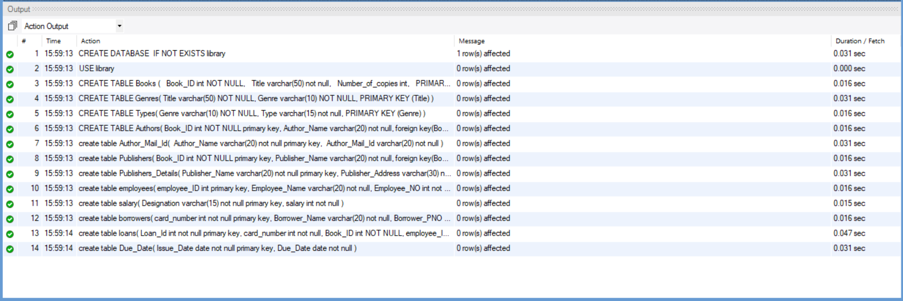

**INSERTION OF VALUES INTO DATABASE**

insert into Books values('ISBN 99921-58-10-7','basic physics',5);

insert into Books values('ISBN 9971-5-0210-0','basic maths',7);

insert into Books values('ISBN 960-425-059-0','marvel',9);

insert into Books values('ISBN 80-902734-1-6','atomic habits',2);

insert into Books values('ISBN 80-906734-4-8','mastering creativity',4);

insert into Books values('ISBN 85-359-0277-5','walter sawitch',7);

insert into Books values('ISBN 85-359-0457-5','c++ primer',4);

insert into genres values ('basic physics','physics' );

insert into genres values ('basic maths','maths' );

insert into genres values ( 'marvel','comics');

insert into genres values ( 'atomic habits','personality development');

insert into genres values ( 'walter sawitch','computer');

insert into genres values ( 'c++ primeer','computer');

insert into genres values ('mastering creativity','personality development');

insert into Types values ('physics','non fiction' );

insert into Types values ('maths','non fiction' );

insert into Types values ('marvel',' fiction' );

insert into Types values ( 'personality development','non fiction');

insert into Types values ('computer' ,'non fiction' );

insert into Authors values ('ISBN 99921-58-10-7', 'HC Verma');

insert into Authors values ('ISBN 9971-5-0210-0', 'iyenger');

insert into Authors values ('ISBN 960-425-059-0', 'stan lee');

insert into Authors values ('ISBN 85-359-0277-5', 'walter sawitch');

insert into Authors values ('ISBN 85-359-0457-5', 'stanley');

insert into Authors values ('ISBN 80-902734-1-6', 'james ');

insert into Authors values ('ISBN 80-906734-4-8', 'james ');

insert into Author_Mail_Id values('HC Verma','hcverma@gmail.com');

insert into Author_Mail_Id values('iyenger','iyer@gmail.com');

insert into Author_Mail_Id values('walter sawitch','walter@gmail.com');

insert into Author_Mail_Id values('stanley','stan@gmail.com');

insert into Author_Mail_Id values('stan lee','lee@gmail.com');

insert into Author_Mail_Id values('james','james@gmail.com');

insert into Publishers values('ISBN 99921-58-10-7','khanna');

insert into Publishers values('ISBN 9971-5-0210-0','khanna');

insert into Publishers values('ISBN 960-425-059-0','M.S.K');

insert into Publishers values('ISBN 80-902734-1-6','MCgrawhill');

insert into Publishers values('ISBN 80-906734-4-8','MCgrawhill');

insert into Publishers values('ISBN 85-359-0277-5','MCgrawhill');

insert into Publishers values('ISBN 85-359-0457-5','MCgrawhill');

insert into Publishers_Details values ('MCgrawhill','New Delhi','9346907122');

insert into Publishers_Details values ('khanna','Banglore','8765428902');

insert into Publishers_Details values ('M.S.K','vijayawada','9705242829');

insert into employees values (1,'Rajesh','6472896524','Librarian','2019-08-23');

insert into employees values (2,'varun','913262829','Librarian','2004-03-03');

insert into employees values (3,'anil','9268275347','cleaner','2015-05-24');

insert into employees values (4,'vasu','8726352739','security','2020-07-25');

insert into employees values (5,'tharun','9826253765','security','2015-08-03');

insert into employees values (6,'vamsi','9725143789','Manager','2003-12-16');

insert into salary values('Librarian',8000);

insert into salary values('Manager',12000);

insert into salary values('cleaner',4000);

insert into salary values('security',3000);

insert into borrowers values(100,'rupesh','9826457836','student','2012-01-24','2021-05-24','nitw');

insert into borrowers values(101,'akash','9264758264','teacher','1996-06-20','2022-02-19','chourasta');

insert into borrowers values(102,'alekya','9264848264','bussiness man','2000-05-22','2019-11-12','kazipet');

insert into borrowers values(103,'vishnu','9174035284','student','2015-12-24','2022-08-24','nitw');

insert into borrowers values(104,'yochana','6972647593','pilot','1987-05-02','2015-01-14','hanumakonda');

insert into borrowers values(105,'ruthvika','8265036279','manager','1993-02-14','2020-08-08','manchiryal');

insert into borrowers values(106,'jayanth','9363726280','director','1994-05-24','218-07-29','nitw');

insert into loans values(1000,103,'ISBN 99921-58-10-7',1,'2022-01-17','2022-06-23');

insert into loans values(1001,104,'ISBN 99921-58-10-7',2,'2021-11-08','2022-03-23');

insert into loans values(1002,100,'ISBN 80-902734-1-6',2,'2022-05-08','2022-06-18');

insert into loans values(1003,105,'ISBN 960-425-059-0',1,'2022-01-17','2022-06-18');

insert into loans values(1004,105,'ISBN 9971-5-0210-0',1,'2016-04-27','2016-08-08');

insert into loans values(1005,102,'ISBN 80-902734-1-6',2,'2021-11-08','2022-06-18');

insert into loans values(1006,104,'ISBN 80-906734-4-8',1,'2014-12-08','2014-04-08');

insert into Due_Date values('2022-01-17','2022-02-17');

insert into Due_Date values('2021-11-08','2021-12-08');

insert into Due_Date values('2022-05-08','2022-06-08');

insert into Due_Date values('2016-04-27','2016-05-27');

insert into Due_Date values('2014-12-08','2015-01-08');